* 3LED (Traffic Signal) :-

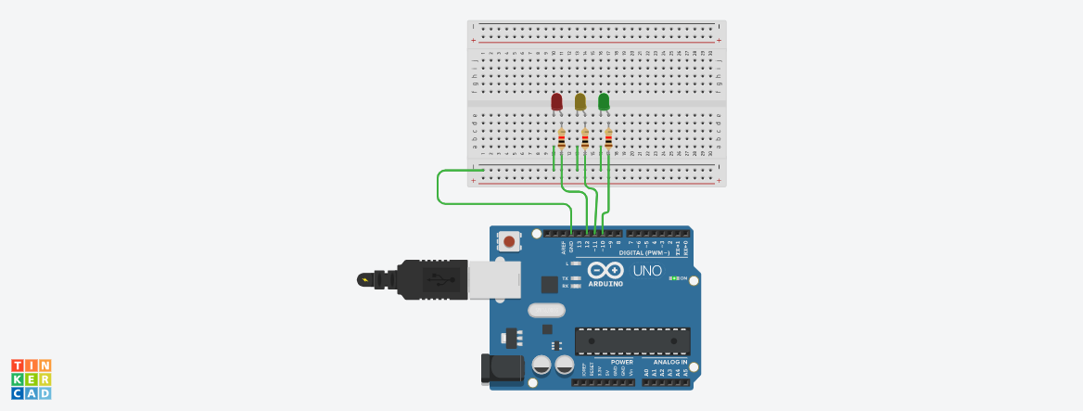

**Circuit diagram**

* **Description :-**

This project is working on Traffic signal. Like in this project 3LED are connected with Arduino and it will glow in sequence after 1 second movement, also it will control as a traffic signal light.

* **Application :-**

Traffic signal, automotive lighting system, Flash when ringing phone etc.

* **Working Principle:-**

In this project the working of 3 LED in a row successively light up and dim one after another. The principle of this experiment is simply to turn on three led in turn. The three LEDs are connected to pin 12, 11, and 10 on arduino respectively. Other one leg of led is connected with ground. In this right leg of led Anode(+ ve) is connected with resistor. Set this all pin as High level and the corresponding LED at the pins will light up. Control the time of each LED brightening and you will see flowing lights. Here we are trying to 3 LED red, yellow, green on or off respectively.

* **Circuit Connection :-**

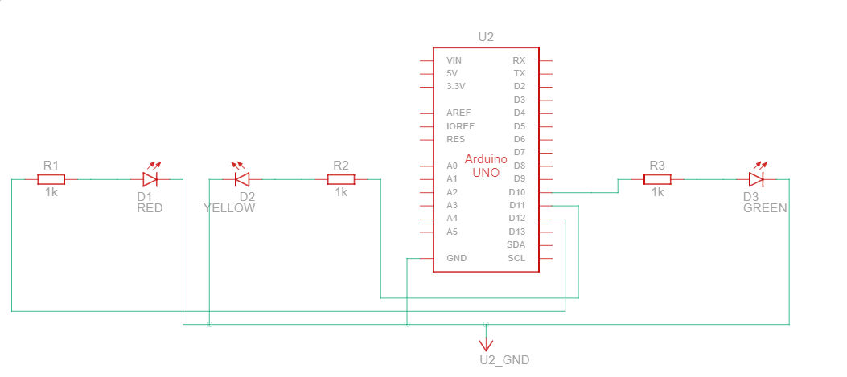

* Component List :-

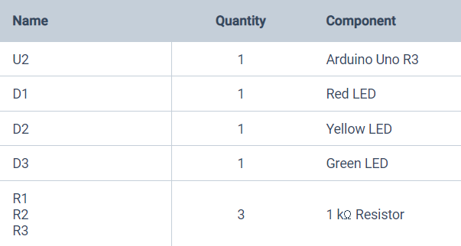

* **CODES :-**

// C++ code

//

void setup()

{

pinMode(12, OUTPUT);

pinMode(11, OUTPUT);

pinMode(10, OUTPUT);

}

void loop()

{

digitalWrite(12, HIGH);

delay(1000); // Wait for 1000 millisecond(s)

digitalWrite(12, LOW);

delay(1000); // Wait for 1000 millisecond(s)

digitalWrite(11, HIGH);

delay(1000); // Wait for 1000 millisecond(s)

digitalWrite(11, LOW);

delay(1000); // Wait for 1000 millisecond(s)

digitalWrite(10, HIGH);

delay(1000); // Wait for 1000 millisecond(s)

digitalWrite(10, LOW);

delay(1000); // Wait for 1000 millisecond(s)

}